Capstone Project-I
Report
on

“Object Detection for Blind People”

Submitted By
Parth J. Patel | 202302626010054
Parth K. Patel | 202302626010055
Aarjav Sheth | 202302626010072
Amit Chauhan | 202302626010073

Under the Guidance of
Twinkle K. Patel
Assistant Professor



Faculty of Engineering and Technology
GLS University
Academic Year
(2025-2026)



CERTIFICATE

This is to certify that the project report entitled “ Object Detection for Blind People ” has been satisfactorily carried out by the following students

Parth J. Patel | 202302626010054
Parth K. Patel | 202302626010055
Aarjav Sheth | 202302626010072
Amit Chauhan | 202302626010073

under my guidance in the fulfillment of the course Capstone Project-I (222601506) work during the academic year 2025-2026.

(Twinkle K. Patel) |  | (Dr. Madhuri Chopade)
Internal Guide |  | Capstone Project-I Coordinator
Acknowledgment

I would like to express my sincere gratitude to everyone who supported me throughout the development of my project, “Object Detection for Blind People.”

I am truly thankful to my Capstone-I Coordinator Dr. Madhuri Chopade, for providing continuous support, guidance, and valuable suggestions during the entire project period. Their encouragement helped me stay focused and complete this work successfully.

I would also like to express my deep appreciation to my Project Guide Twinkle K. Patel, for their constant guidance, useful feedback, and motivation. Their insights played an important role in improving the quality of this project.

I am also grateful to my teammates for their cooperation, ideas, and hard work throughout the project development.

This project has been a great learning experience, and I sincerely value the help of everyone who contributed directly or indirectly.

Sincerely,
Parth J. Patel
Parth K. Patel
Aarjav Sheth
Amit Chauhan

Abstract

This project, “Object Detection for Blind People” aims to support visually impaired individuals by providing real-time assistance using artificial intelligence and computer vision. The proposed system uses a mobile application that detects objects, reads text from signboards, recognizes currency, summarizes documents, and provides voice-based guidance to help users navigate safely.

The application integrates YOLO-based object detection, OCR for text reading, an NLP model for summarization, and GPS navigation support. All detected information is delivered to the user through a text-to-speech engine, ensuring hands-free and accessible interaction. The system also stores activity logs for future reference.

This project demonstrates how modern AI technologies can be combined to create a practical assistive tool for blind and visually impaired individuals. The solution is designed to be user-friendly, efficient, and capable of improving independent mobility and daily accessibility for its users.

Content

Sr. | Particular | Page No.
 | Certificate | I
 | Acknowledgment | II
 | Abstract | III
 | Table of Content | IV
1. | Introduction | 1
2. | Literature Review | 3
3. | Project Methodology/ Analysis/ Design (wireframes/diagrams) | 6
4. | Project Requirement | 15
 | 4.1 Functional | 15
 | 4.2 Non- Functional | 16
 | 4.3 Prototype with Screenshots | 17
5. | Tools & Technologies | 19
6. | Implementation (Optional) | 22
7. | Conclusion & Future Work | 26
8. | References | 27

Chapter 1:Introduction

Visual impairment is one of the major challenges faced by millions of individuals across the world. According to global health reports, a large percentage of blind and visually impaired people struggle with day-to-day tasks such as identifying surrounding objects, reading signboards, recognizing currency, and navigating unfamiliar environments. Traditional support tools like white canes and guide dogs provide only limited assistance. They help detect obstacles but cannot convey detailed information about object types, text content, directions, or other environmental cues. As a result, visually impaired individuals often rely heavily on others, which affects their independence and confidence.

Advancements in Artificial Intelligence (AI), Machine Learning (ML), Computer Vision, and Natural Language Processing (NLP) offer powerful opportunities to create assistive technologies that can support such individuals in a more meaningful way. With the increasing availability of smartphones equipped with good-quality cameras and sensors, it has become possible to run AI-based models directly on mobile devices and provide real-time assistance to users.

This project, titled “Object Detection for Blind People,” aims to leverage these technologies to develop a mobile application capable of detecting objects, reading text, recognizing currency, providing navigation help, and generating voice-based feedback. The main objective is to offer a portable, affordable, and user-friendly solution that improves accessibility and independence for blind and visually impaired people.

The application integrates multiple modules such as YOLO-based real-time object detection, OCR for reading signboards and documents, CNN-based currency recognition, GPS and map-based navigation, document summarization, and a voice-powered AI assistant. Every detection or output is converted into speech using a text-to-speech engine so that users can interact with the system completely hands-free.

Overall, this project demonstrates how modern AI systems can be combined into a single mobile app to support blind users in understanding their surroundings and performing daily activities more safely and independently. The solution focuses on being practical, accessible, and easy to use, making it a valuable tool for visually impaired individuals.

Chapter 2: Literature Review

Assistive technologies for visually impaired individuals have been a growing area of research, especially with advancements in Artificial Intelligence (AI), Computer Vision, and Natural Language Processing (NLP). Over the years, several tools and systems have been developed to help blind users navigate and interact with their environment, but many still lack real-time object understanding, multi-function integration, and accessibility features.

2.1 Traditional Assistive Tools
White Canes and guide dogs have long been used by visually impaired individuals.
- White canes detect obstacles within close range but cannot identify what the object actually is.
- Guide dogs provide mobility assistance but require training and high maintenance.
These tools do not provide detailed context such as object type, text on a signboard, currency denomination, or directions.

2.2 Smart Canes and Wearable Devices
Recent research introduced smart canes equipped with ultrasonic sensors to detect obstacles.
- While useful, smart canes only detect the presence of an obstacle, not its type.
- They also cannot read text or assist in navigation beyond basic warnings.
Devices like OrCam MyEye use camera-based image interpretation to read text and identify some objects.
- These devices are effective but extremely expensive.
- They do not offer integrated features such as document summarization or AI-based voice interaction.

2.3 Mobile-Based Assistive Applications
Several apps have been developed to help blind users using smartphone cameras:
- Seeing AI (Microsoft)
  - Provides object detection, reading text, and scene descriptions.
  - Limited support for navigation or document summarization.
- Google Lookout
  - Offers object detection, currency recognition, and OCR.
  - Does not provide AI assistant capabilities or advanced NLP summarization.
- TapTapSee
  - Uses cloud image recognition.
  - Slower response time, requires internet, and lacks multiple assistive features.
Although these applications offer helpful functionality, no single platform provides all features needed for complete assistance.

2.4 Research on Object Detection
Studies show that YOLO (You Only Look Once) models offer high accuracy and real-time performance, making them suitable for applications requiring low latency.
YOLOv5 and YOLOv8 are widely used due to their speed on mobile devices.

2.5 Research on OCR (Optical Character Recognition)
Tesseract OCR remains one of the most effective open-source text recognition tools.
It has been used in several research studies to extract text from images, such as reading signboards or documents.

2.6 Research on NLP-Based Summarization
Large language models (LLMs) like T5 and BART are known for their ability to generate high-quality text summaries.
These models allow document summarization to be integrated into assistive apps.

2.7 Gap Identified in Existing Research
After studying existing systems and research papers, several gaps were identified:
- No single system provides object detection, OCR, currency recognition, navigation, summarization, and AI assistance together.
- Many existing solutions require internet connectivity, causing delays.
- Some systems are too expensive, not practical for everyday use.
- User interfaces are not always designed for blind-friendly operation.
- Multi-language voice output is rarely supported.

2.8 Summary of Literature Findings
The literature highlights the need for:
- A single integrated system covering multiple assistive functions.
- Real-time processing that works offline.
- A simple voice-based interface.
- Affordable smartphone-based solutions.

This project aims to combine modern AI modules into one mobile app to address these gaps and provide a more complete assistive solution for blind individuals.

Chapter 3: Project Methodology/ Analysis/ Design (wireframes/diagrams)

This chapter explains the overall methodology used to develop the Object Detection for Blind People application. It includes requirement analysis, system workflow, development methodology, and the design approach supported by diagrams and wireframes.

3.1 Project Methodology
The project follows a Phased Development Approach, combining elements of the Agile methodology to allow iterative testing and refinement.
Step 1: Requirement Gathering
- Understanding challenges faced by visually impaired individuals.
- Identifying essential features such as object detection, OCR, currency recognition, navigation, summarization, and AI assistance.
- Studying existing applications (Seeing AI, Lookout) to identify gaps.
Step 2: Feasibility Study
- Evaluated hardware compatibility with mobile devices.
- Analysed the performance of models like YOLOv5, Tesseract OCR, and T5 summarizer.
- Ensured offline performance where possible.
Step 3: System Design
- Created flow diagrams, UML diagrams, and the overall system architecture.
- Designed the user interface with simple layouts and full voice accessibility.
Step 4: Model Training & Integration
- YOLO model prepared for real-time object detection.
- OCR and Currency recognition modules tested.
- Navigation module integrated with GPS and Maps API.
Step 5: Implementation
- All modules built and integrated in the Android application.
- Added Text-to-Speech, voice commands, and database logging.
Step 6: Testing & Improvement
- Functional testing (each module tested independently).
- User feedback-based improvements.
- Performance and accuracy testing under various lighting conditions.

3.2 Project Analysis
Based on user needs and research, the system must:
- Work hands-free using voice commands.
- Provide real-time detection with accurate audio output.
- Be easy to use for blind users.
- Work in low-light and busy environments.
- Support multiple Indian languages.
- Maintain logs for usage patterns.
The app analyses data from:
- Camera input (object, signboard, currency)
- GPS (for navigation)
- Microphone (voice commands)
- AI models (summarization & assistant)

3.3 System Workflow
Overall Working:
- User opens the application or gives a voice command.
- Camera captures the real-time frame.
- Frame is passed to:
  - YOLOv5 model → Object detection
  - Tesseract OCR → Signboard/Document reading
  - Currency model → Denomination detection
- Navigation module processes GPS location.
- NLP model summarizes extracted text.
- Output is converted to speech using TTS.
- Log is saved in local database.

3.4 Wireframes
Home Screen
- Shows main features: Object Detection, Currency Recognition, OCR, Navigation, AI Assistant, Logs.
Object Detection Screen
- Shows camera feed with simple layout.
- Voice output speaks object name.
OCR & Summarization
- Text is extracted and displayed (for sighted helpers), and spoken aloud.
Navigation Screen
- Start/Stop navigation.
- Voice-based directions.
Activity Log Screen
- Shows the list of previous actions with timestamps.

3.5 System Design (UML Diagrams & Architecture)
Your report will include the following diagrams:

3.5.1 Use Case Diagram
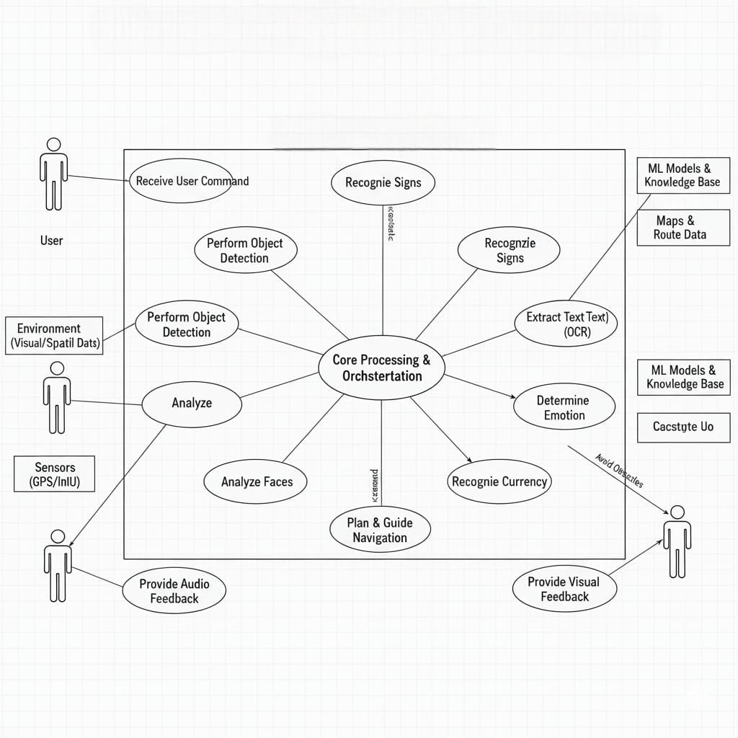

3.5.2 Class Diagram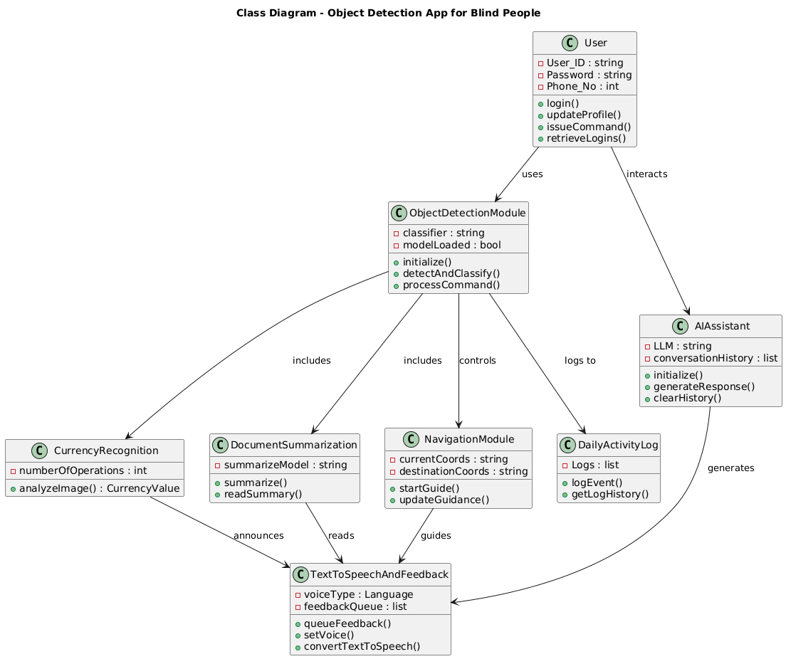

3.5.3 Sequence Diagram
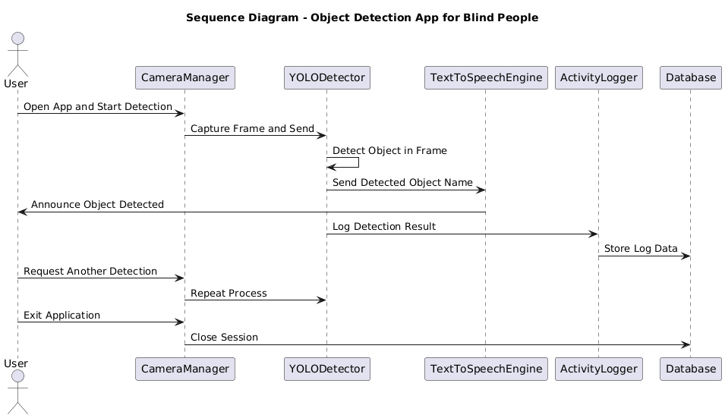

3.5.4 Activity Diagram
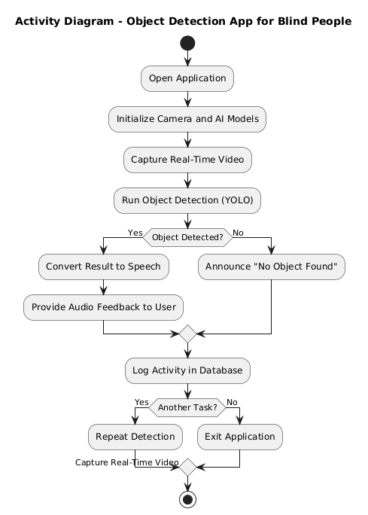

3.5.5 State Diagram
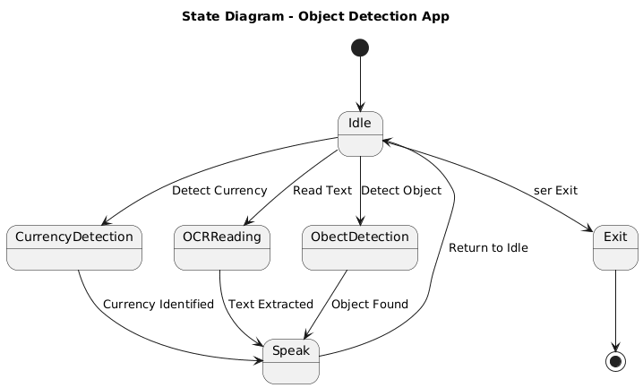
3.5.6 Data Flow Diagram (DFD)
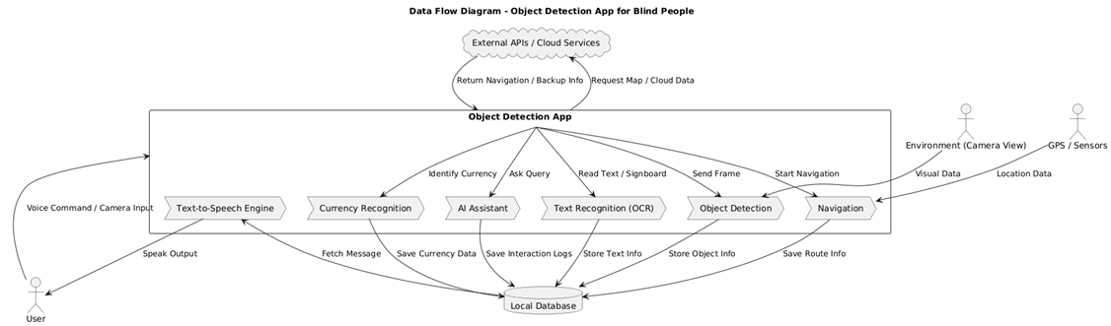

3.6 Summary of Design Approach
The design focuses on:
- Accessibility: 100% voice-controlled interface.
- Modularity: Each feature (detection, OCR, navigation) is a separate module.
- Real-time Processing: YOLO and OCR optimized for mobile.
- User-Friendly Interaction: Simple screens + audio feedback.
- Reliability: Local logs, offline processing where possible.

Chapter 4: Project Requirement

This chapter lists all the requirements necessary to design, develop, and implement the Object Detection for Blind People application. Requirements are divided into functional, non-functional, and prototype (UI) requirements.

4.1 Functional Requirements
Functional requirements describe what the system must do.
These represent the core functions of your mobile application:

1. User Authentication
- The system must allow the user to log in or skip login.
- The app should support basic profile settings such as language preference and voice speed.

2. Object Detection
- The app must detect objects in real time using the mobile camera.
- The system should identify object names and speak them aloud.
- It should work with YOLOv5 / YOLOv8-lite models.

3. Currency Recognition
- The system must recognize Indian currency notes.
- It must speak the denomination (₹10, ₹20, ₹50, ₹100, ₹200, ₹500, ₹2000).
- It must work even when part of the currency is folded.

4. Text Recognition (OCR)
- The system should read signboards, documents, and short printed text.
- Extracted text must be narrated through voice output.

5. Document Summarization
- The app must summarize a full document or long text into a short, meaningful summary.
- NLP models like T5/BART must be used for summarization.
- The summary must be provided as voice output.

6. AI Voice Assistant
- The app must respond to user questions through speech.
- It should support voice commands such as:
“Read text,” “Detect object,” “Where am I?”, “Start navigation,” etc.

7. Real-Time Navigation
- The app must provide turn-by-turn audio navigation using GPS.
- It should announce directions like “Turn left,” “Move straight,” etc.
- The module uses Google Maps API.

8. Daily Activity Logs
- The app must store all activities such as object detected, currency read, text extracted, etc.
- Logs must be stored in a local SQLite/Room database.

9. Multi-Language Support
- The app must support at least English and one regional language (Gujarati/Hindi).
- All outputs must be spoken in the selected language.

10. Text-to-Speech Output
- Every detection must be converted into audio automatically.
- No reading or touching required by the user.

4.2 Non-Functional Requirements
Non-functional requirements describe quality, performance, and constraints of the system.

1. Usability
- Interface must be minimal and 100% accessible for blind users.
- Large buttons + full voice control must be provided.
2. Performance
- Object detection must work in near real-time (approx. 15–20 FPS).
- OCR and summarization must generate output within a few seconds.
3. Accuracy
- Object detection accuracy above 80%.
- Currency recognition accuracy above 90% under good lighting.
4. Reliability
- The app should work in offline mode except navigation.
- Must recover correctly from errors like low light or motion blur.
5. Scalability
- System should allow additional features in future:
– face recognition
– obstacle distance
– cloud backup
– more languages
6. Security
- User data must be stored securely in local database.
- No online sharing without permission.
7. Compatibility
- Works on Android devices with:
  - Minimum OS: Android 8.0
  - RAM: 3GB or above
  - Camera: 8MP or above
8. Maintainability
- Code should be modular (each feature in separate module).
- Easy for future updates and improvements.

4.3 Prototype with Screenshots
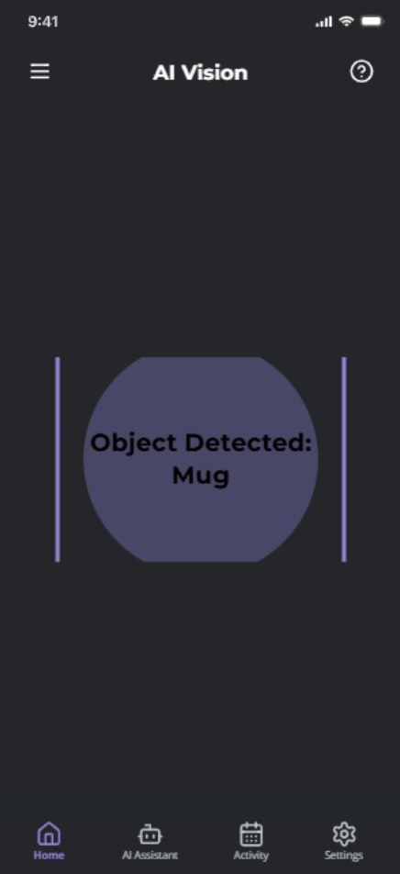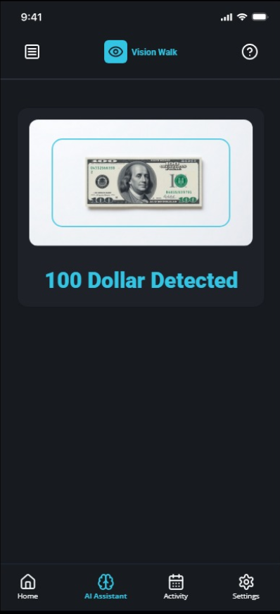

1. Splash Screen
- Displays app name and prepares the environment.
2. Home Screen
- Shows main features:
  - Object Detection
  - Currency Recognition
  - OCR
  - Summarization
  - Navigation
  - AI Assistant
  - Activity Logs
3. Object Detection Screen
- Opens the camera and detects real-time objects.
- Speaks: “Chair detected,” “Person ahead,” etc.
4. Currency Recognition Screen
- User points the camera at currency.
- App announces: “Two hundred rupees.”
5. OCR / Signboard Reading
- Captures image → converts to text → speaks aloud.
6. Document Summarization Screen
- User selects document text → app generates summary → speaks it.
7. Navigation Screen
- Allows user to set destination via voice commands.
- Provides turn-by-turn instructions.
8. AI Assistant Screen
- User asks questions such as “What is the weather?” or “Summarize this text.”
- App responds via voice.
9. Activity Log Screen
- Shows detailed history:
  - Time
  - Detection type
  - Output
  - Status

Chapter 5: Tools & Technologies

The Object Detection for Blind People application uses a combination of advanced software tools, AI frameworks, and mobile development technologies. These tools help implement real-time object detection, text recognition, navigation, currency classification, voice interaction, and data management.
This section describes the technologies used in building each module of the system.

5.1 Software Tools
1. Android Studio
- Used for developing the mobile application.
- Supports Java/Kotlin for app development.
- Provides device emulators for testing.
- Integrates with external libraries for camera access, TTS, and ML models.
2. Visual Studio Code (VS Code)
- Used for writing Python scripts.
- Helpful for training models, testing detection algorithms, and running OCR modules.
3. GitHub
- Used for version control.
- Allows easy tracking, collaboration, and backup of project files.

5.2 Programming Languages
1. Kotlin / Java
- Used to develop the front-end interface and application logic.
- Supports Android APIs for camera, microphone, GPS, and text-to-speech.
2. Python
- Used for model training, dataset preparation, OCR testing, and AI assistant logic.
- Python libraries (PyTorch, TensorFlow, OpenCV) are essential for model development.

5.3 Machine Learning & AI Frameworks
1. PyTorch
- Framework used to train and deploy YOLO models.
- Lightweight, fast, and suitable for mobile optimization.
2. TensorFlow / TFLite (Optional)
- Alternative ML framework for on-device inference.
- Useful for currency recognition and NLP tasks.
3. OpenCV
- Library for image processing.
- Used for:
  - Frame capture
  - Preprocessing
  - Image resizing
  - Edge detection
  - Contour extraction
4. YOLOv5 / YOLOv8-lite
- Real-time object detection algorithm.
- Provides bounding boxes and labels at high speed.
- Works efficiently on mobile devices.
5. Tesseract OCR
- Extracts text from images (signboards, documents).
- Useful for reading street signs, labels, and printed content.
6. NLP Models (T5 / BART)
- Used for document summarization.
- Converts long text into short, meaningful summaries.
7. LLM-based AI Assistant (LLaMA / GPT APIs)
- Powers voice interactions.
- Helps user control features, ask questions, or summarize text.

5.4 Speech & Voice Technologies
1. Text-to-Speech (TTS) Engine
- Converts all outputs into voice.
- Supports local languages.
- Libraries used:
  - gTTS (Google Text-to-Speech)
  - pyttsx3
  - Android Speech API
2. Speech Recognition
- Recognizes voice commands from the user.
- Uses Android SpeechRecognizer or Google Voice API.

5.5 Navigation & Location Technologies
1. Google Maps API
- Provides real-time navigation.
- Converts GPS coordinates into turn-by-turn instructions.
2. GPS Sensor (Mobile Device)
- Captures user’s current location for navigation module.

5.6 Database Technologies
SQLite / Room Database
- Stores:
  - User activity logs
  - Feature usage history
  - Preferences and settings
- Local storage ensures privacy and offline access.

5.7 Hardware Requirements
1. Android Smartphone
- Minimum OS: Android 8.0
- RAM: 3GB or above
- Camera: 8MP or higher for reliable detection
2. Internet (Optional)
- Required for:
  - AI Assistant
  - Map API
  - Some model updates
- Not required for offline detection or OCR.

5.8 Supporting Libraries
- NumPy
- Pandas
- Matplotlib (for model training visualization)
- TorchVision
- Pillow (PIL)
- Firebase (Optional for cloud logging)

Chapter 6: Implementation

The implementation phase of the Object Detection for Blind People project involves integrating multiple AI modules, mobile development components, and system-level functionalities to create a complete and user-friendly application. This section describes how each feature, model, and module of the app was developed and integrated into the final system.

6.1 Overview of Implementation
The application is implemented as an Android-based mobile app powered by AI and computer vision models. The main implementation steps include:
- Setting up the Android environment
- Integrating the camera module
- Building and optimizing the YOLO model
- Implementing OCR and currency recognition
- Adding navigation and location services
- Integrating the AI assistant
- Adding text-to-speech and voice control
- Creating database storage and logs
- Designing a simple, accessible user interface
Each module is developed separately and then combined into a single unified application.

6.2 Module Implementation Details

6.2.1 Object Detection Module (YOLO)
- YOLOv5/YOLov8-lite models were trained or downloaded and converted for mobile compatibility.
- The model processes real-time frames from the camera.
- For each frame:
  - Objects are identified
  - Bounding boxes are drawn
  - Labels are extracted
- The detected object name is passed to the Text-to-Speech (TTS) engine.
Output:
The user hears voice feedback such as “Dog ahead” or “Chair detected.”

6.2.2 OCR Module (Signboard & Text Reading)
- Implemented using Tesseract OCR.
- Captures an image → preprocesses it → extracts text.
- Works for signboards, printed text, and labels.
- Extracted text is spoken aloud.
Example:
Input: A signboard “Library →”
Output: “Library arrow right.”
6.2.3 Currency Recognition Module
- Uses a CNN-based classifier to recognize:
  - ₹10
  - ₹20
  - ₹50
  - ₹100
  - ₹200
  - ₹500
- Handles partially folded or angled currency notes.
Output:
“Two hundred rupees.”

6.2.4 Document Summarization Module
- Uses NLP models like T5 or BART.
- Extracted text from OCR is summarized into short output.
- The summary is narrated through TTS.
Example:
Input: 5-paragraph text
Output: 2–3 line summary spoken aloud.

6.2.5 AI Assistant Module
- Voice-based assistant implemented using:
  - LLaMA model OR
  - GPT API OR
  - Offline NLP model
- Enables natural conversation and voice commands.
- Helps blind users interact with the app hands-free.
Commands include:
- “Detect object”
- “Read text”
- “Where am I?”
- “Summarize this document”

6.2.6 Navigation Module
- Uses GPS + Google Maps API.
- Accepts destinations via voice input.
- Provides turn-by-turn navigation through audio.
Examples:
“Turn left in 20 meters.”
“You have reached your destination.”

6.2.7 Text-to-Speech (TTS) Module
- Converts all detection results into speech.
- Supports multiple languages.
- Uses:
  - Google Text-to-Speech
  - pyttsx3
  - Android Speech Services
Output:
Natural, clear voice feedback for every module.

6.2.8 Activity Log Module (Local Database)
- Implemented using SQLite / Room Database.
- Saves:
  - detections
  - text reads
  - currency recognized
  - navigation reports
  - summaries
Logs help track user interaction and can be analyzed later.

6.2.9 User Interface Implementation
The UI is designed to be simple and minimal for blind users:
- Large clickable buttons
- High-contrast icons
- Full voice instructions
- Vibrations for confirmations
- Simple navigation flow
Screens include:
- Splash screen
- Home
- Object detection
- OCR
- Currency recognition
- Navigation
- AI assistant
- Activity logs
- Settings

6.3 Integration of Modules
All modules were integrated into a unified application by:
- Setting up Android CameraX API
- Running YOLO model in background thread
- Connecting OCR to camera capture
- Linking AI assistant with voice recognition
- Connecting GPS with navigation service
- Implementing TTS across all modules
- Creating DB helper class for logs

6.4 Testing During Implementation
Several tests were performed:
- Real-time object detection testing
- Low-light detection testing
- Signboard reading accuracy
- Currency recognition under different angles
- Navigation correctness
- Voice command understanding
- Performance testing on 3GB/4GB RAM devices

6.5 Final Output
The final application:
- Detects objects in real time
- Reads signboards and documents
- Summarizes large text
- Recognizes Indian currency
- Provides full audio navigation
- Responds to voice commands
- Stores daily activity logs
- Supports multiple languages

Chapter 7: Conclusion & Future Work

7.1 Conclusion
The project “Object Detection for Blind People” successfully demonstrates how Artificial Intelligence can be used to support visually impaired individuals in understanding and navigating their surroundings. By integrating multiple technologies such as YOLO object detection, OCR, currency recognition, document summarization, AI voice assistance, and GPS-based navigation, the system provides a comprehensive assistive solution within a single mobile application.
The app enables blind users to identify objects, read text, recognize currency, summarize documents, and receive navigation instructions—all through simple voice-based interaction. The use of a mobile device makes the solution affordable, portable, and practical for daily use.
The overall work proves that modern computer vision and language models can be deployed effectively on smartphones to provide life-changing assistance to visually impaired people. It also highlights the potential of AI to improve accessibility, independence, and quality of life.

7.2 Future Scope
Although the application offers multiple assistive features, there is significant room for improvement and expansion in future versions. The following enhancements can make the system more powerful and user-friendly:
1. Distance & Depth Detection
- Integrating LiDAR, ToF sensors, or stereo vision to estimate object distance (e.g., “Obstacle 2 meters ahead”).
2. Offline Navigation
- Building an offline maps module for places without internet connectivity.
3. Wearable Device Integration
- Connecting the app with smart glasses, smart watches, or smart sticks for hands-free usage.
4. Better Low-Light Performance
- Improving detection accuracy in nighttime and low-light environments using enhanced image preprocessing.
5. Advanced NLP Features
- Adding emotion detection in voice, conversational AI improvements, and better summarization accuracy.
6. Cloud Backup for Logs
- Syncing activity logs and preferences securely to the cloud for cross-device access.
7. Real-Time Hazard Detection
- Detecting sudden obstacles such as stairs, holes, or approaching vehicles for enhanced safety.
8. More Local Languages
- Supporting additional Indian languages like Marathi, Bengali, Tamil, Telugu, Punjabi, etc.
9. Face Recognition
- Identifying familiar people using facial recognition to assist social interactions.
10. Integration with Government Accessibility Services
- Collaborating with assistive technology programs to deploy the app on a larger scale.
Chapter 8: References

- Research papers and publications on real-time object detection using YOLO models.
- Documentation and research material on Tesseract OCR for text extraction.
- Studies related to computer vision applications for visually impaired individuals.
- Official documentation of PyTorch and TensorFlow for model training and deployment.
- Research papers on NLP-based text summarization using T5 and BART models.
- Google Maps API documentation for implementing navigation services in mobile applications.
- Android Developer documentation for CameraX, Text-to-Speech, and Speech Recognition APIs.
- Academic articles on assistive technologies and accessibility solutions for blind users.
- Existing applications such as Microsoft Seeing AI, Google Lookout, and TapTapSee—reviewed for comparative analysis.
- Books and journals related to Artificial Intelligence, Machine Learning, and Mobile Computing.

